Supplies, Equipment, and Patient Tracking
Software Requirements Specification
For St. Peter’s Hospital

Version 3.0

Revision History
Date | Version | Description | Author
02/FEB/06 | 0.1 | Document setup, definitions, tracking interface | Michael
02/FEB/06 | 0.2 | Introduction, overall description | Tyler P
02/FEB/06 | 0.3 | Formatting of specific requirements section | Tri-Systems
02/FEB/06 | 0.4 | Security personnel related requirements | Bryan
02/FEB/06 | 0.5 | Supply staff related requirements | Kia
02/FEB/06 | 0.6 | Website and visitor information kiosk requirements. | Odysseus
02/FEB/06 | 0.7 | Healthcare staff related requirements | Chris
02/FEB/06 | 0.8 | Administrative personnel related requirements | Tyler G
02/FEB/06 | 0.9 | Proofreading and formatting of document | Michael
03/FEB/06 | 1.0 | Final proofing, glossary additions. | Michael, Kia, Odysseus, Tyler P
05/FEB/06 | 1.1 | Client inspection on version 1.0 | St. Peter’s Hospital
13/FEB/06 | 1.2 | Request for Clarification on RS 1.1 | Tri-Systems
20/FEB/06 | 1.3 | Porting of document to RequisitePro | Tyler P
21/FEB/06 | 1.4 | Realignment of functional requirements, additions to non-function requirements, rewording of overall description | Tyler P
09/MAR/06 | 1.5 | Adding requirements related to BC provincial medical records, from client negotiations | Kia
10/MAR/06 | 1.6 | Added security and authorization features based on feedback during client negotiations. | Tyler G
10/MAR/06 | 1.7 | Addition of System Architecture, Use Case Diagram, and System Requirements | Michael, Brian, Kia, Chris and Tyler P
10/MAR/06 | 1.8 | Addition of Change Log | Odysseus
10/MAR/06 | 2.0 | Final proof and posting | Tri-Systems
27/MAR/06 | 2.2 | Update RequisitePro document with changes made night of submitting RS 2.0. | Michael
28/MAR/06 | 2.3 | Added rational requirement type and traced to requirements.  Incorporate client feedback into document (up to section 3.1.6). | Michael
03/APR/06 | 2.4 | Incorporate outstanding client feedback into document | Tyler P
04/APR/06 | 2.5 | Proofreading and refining of new and existing requirements. | Michael, Odysseus
04/APR/06 | 2.6 | Inserting test scenarios into the document. | Odysseus, Tyler G, Michael, Tyler P
05/APR/06 | 2.7 | Inserting prototype descriptions into the document. | Kia, Brian, Tyler P
06/APR/06 | 2.8 | Document revisions. | Tri-Systems
06/APR/06 | 2.9 | Inserting traceability matrices. | Michael, Tyler P
06/APR/06 | 3.0 | Final revisions and proofreading. | Tri-Systems

Table of Contents
1. Introduction 1
1.1 Purpose 1
1.2 Scope 1
1.3 Definitions, Acronyms and Abbreviations 1
1.4 References 2
1.5 Overview 2
2. Overall Description 3
2.1 Product Perspective 3
2.2 Product Functions 3
2.3 User Characteristics 4
2.3.1 Administrative personnel 4
2.3.2 Healthcare personnel 4
2.3.3 Security personnel 4
2.3.4 Supply staff 4
2.3.5 Patients and Visitors 4
2.4 Constraints 4
2.5 Assumptions and Dependencies 4
2.5.1 The current Oracle DBMS will be available for use by the new system 5
2.5.2 User computers are available and networked to the hospital’s Intranet 5
2.5.3 Security cards have been issued and readers are located at computers where needed 5
2.5.4 Approval has been granted to access the provincial EMS system 5
3. Specific Requirements 5
3.1 Functionality 5
3.1.1 Patient medical records may be accessed 5
3.1.2 The system will track the current locations of patients in the hospital. 7
3.1.3 Medical equipment shall be recorded, tracked, and signed out 8
3.1.4 The system shall store and monitor stock information 8
3.1.5 The system shall store room and bed availability status 9
3.1.6 Hospital and patient visitation information shall be publicly available 9
3.1.7 Users and groups may be created and access permissions shall be modified 10
3.1.8 Security personnel may monitor patients and equipment in real time 11
3.2 Usability 11
3.2.1 Users shall be able to learn how to use the system within 16 hours of training 11
3.2.2 The user interfaces shall be intuitive 11
3.2.3 Tracking hardware must be robust and unobtrusive 12
3.2.4 Check-in time shall take a maximum of 15 seconds in the event of an emergency 12
3.3 Reliability 12
3.3.1 Patient medical records must be available 100% of the time 12
3.3.2 Daily backups of medical record, equipment status, and supply stock databases will be performed 12
3.4 Performance 12
3.4.1 The location updates shall be propagated to the system within 20 seconds of detection 12
3.4.2 Visitor information kiosks shall handle transactions from a minimum of 2000 users per day 12
3.4.3 The hospital website shall support a minimum of 20,000 users per day 12
3.4.4 The disk space on the database server shall never exceed 75% capacity 13
3.5 Supportability 13
3.5.1 The system shall be upgradeable on a modular basis 13
3.5.2 Administrative personnel shall have direct access to the Oracle DBMS software 13
3.5.3 Existing databases will be migrated to the Oracle DBMS 13
3.5.4 Changes to provincial database will require an update to be applied 13
3.6 Design Constraints 13
3.6.1 The user interfaces shall run on the existing staff computers to access the system 13
3.6.2 Software components which users do not have access to shall in no way be displayed to them 13
3.7 Online User Documentation and Help System Requirements 13
3.7.1 The website shall host a help file for all of its functionality 13
3.7.2 Each system user group shall have a customized manual 13
3.8 Purchased Components 14
3.8.1 Visitor information kiosks must meet the following specifications: 14
3.8.2 System devices will be equipped with backup battery supplies 14
3.8.3 The system shall require additional servers for redundancy and backups 14
3.9 Interfaces 14
3.9.1 User Interfaces 14
3.9.2 Hardware Interfaces 14
3.9.3 Software Interfaces 15
3.9.4 Communications Interfaces 16
3.10 Licensing Requirements 16
3.11 Legal, Copyright and Other Notices 16
3.12 Applicable Standards 16
3.12.1 All website components shall be programmed with valid XHTML 1.0 Transitional markup 16
3.12.2 User interfaces must adhere to the accessibility standards 16
4. System Architecture 17
4.1 Overall Architecture 17
4.2 Software Modules 17
4.2.1 Administration Module 17
4.2.2 Patient Module 17
4.2.3 Equipment Module 18
4.2.4 Supplies Module 18
4.2.5 Web/Visitor Module 18
4.2.6 Security Module 18
4.2.7 Tracking Core 18
4.3 Use Cases 19
4.3.1 Use Case 1: Finding and Editing Information for Patient 20
4.3.2 Use Case 2: Finding and Editing Information for Equipment 21
4.3.3 Use Case 3: Signing out equipment 22
4.3.4 Use Case 4: Using the Kiosk/Website 23
4.3.5 Uses Case 5: Creating users, user groups, and setting permissions 24
4.3.6 Use Case 6: Adding and Removing Tracking Notifications 26
4.3.7 Use Case 7: Creating an In-House Supply Order 27
4.4 Prototypes 29
4.4.1 Main Menu 29
4.4.2 Patient Information Screen 30
4.4.3 Patient Location Screen 31
4.4.4 Patient Check-In and Check-Out Screen 32
Appendix A: Requirement Priority 33
Appendix B: Traceability Matrices 34
Appendix C: Change Log 37

Software Requirements Specification

Introduction

Purpose
The purpose of this document is to fully describe the software requirements for the Supplies, Equipment and Patient Tracking (SEPT) system that will be developed for St. Peter’s Hospital. These requirements were created in response to a request for proposals from St. Peter’s Hospital and have been developed through further elicitation, negotiations, and feedback.
The intended audience of this document includes the prospective developers of the software and the personnel at St. Peter’s who are assisting in assessing the completeness and accuracy of the requirements.

Scope
The SEPT system will integrate and improve upon the existing systems used by St. Peter’s Hospital in the following ways:
- By providing access to detailed medical records and automatic tracking of a patient’s position in the hospital;
- By providing an in depth medical equipment interface with electronic sign out request and automatic location tracking capabilities; and
- By maintaining supply stock information within the system to ensure that stock does not run out.
A web interface will also be provided for visitors and patients to access from their home computers and on-site kiosks that will serve general hospital information.
The goal of the system is to more easily facilitate all administrative activities and information management tasks at the hospital, decrease the loss of expensive medical equipment, and reduce visitor line-ups at information desks.

Definitions, Acronyms and Abbreviations
Database A database is a collection of information stored on a computer in a systematic way, such that a computer program can consult it to answer questions. The software used to manage and query a database is known as a database management system (DBMS). MySQL, PostgreSQL, Oracle and Microsoft SQL are a few of the common DBMS.
EMS The EMS (Electronic Medical Summary) is based on the Cumulative Patient Profile (CPP) as advocated by the College of Physicians and Surgeons under its Committee on Office Medical Peer Assessment (COMPA). The CPP contains a summary of key medical information such as medications, allergies, a problem list and a past medical history etc. The BCMA proposes that EMS be the electronic equivalent of the Cumulative Patient profile.
Healthcare Personnel The term healthcare personnel applies to all medical staff who works in St. Peter hospital, such as doctors and nurses.
HTTP HTTP (or HyperText Transfer Protocol) is a set of rules whose primary method used to transfer information (text, images, sound, video, and other data files) on the World Wide Web.
Internet The Internet is the publicly available worldwide system of interconnected computer networks that transmit data packets by using a standardized Internet Protocol (IP) and many other protocols.
Intranet An intranet is a local area network (LAN) used internally in a company to facilitate communication and access to information that is sometimes access-restricted.
Network Congestion A term used to describe a bottleneck of data packets sent over a network much like a traffic jam with cars. Some of the data trying to be sent will timeout and will be attempted again in the future.
Real-Time An operation within a larger dynamic system is called a real-time operation if the time it takes to complete a task is shorter than the maximum delay that is allowed.
SEPT The acronym for this project: Supplies, Equipment, and Patient Tracking. This project will be known as the “SEPT system” or the “system” from herein.
Stock A supply accumulated for future use.
TCP/IP The Internet protocol suite is the set of communications protocols that implement the protocol stack on which the Internet runs. It is sometimes called the TCP/IP protocol suite, after the two most important protocols in it: the Transmission Control Protocol (TCP) and the Internet Protocol (IP).
Tracking Device A small device that is attached to an object. A tracking sensor will detect when a tracking device is close to it.
Tracing Sensor An electronic device that detects when a tracking device is near by and transmits the information to a tracking interface node.
Tracking Interface Node A computer attached to many tracking sensors that compiles the information it receives.
XML Extensible Markup Language is general purpose markup language that is often used to transfer data over networks. XHTML for website design is an example of another markup language based on XML.

References
IEEE Std 830-1998. IEEE Recommended Practice for Software Requirements Specifications. Available online at http://segal.cs.uvic.ca/seng321/lectures/IEEE_Standard_1998.pdf.
St. Peter’s Hospital. SEPT: Supplies, Equipment and Patient Tracking Request for Proposal v1.0.
January 21, 2005. Available online at http://www.defnad.com/seng321group2client/St_Peters_SEPT_RFPv1.doc.
Wikipedia contributors. Wikipedia, The Free Encyclopedia. Available online at http://en.wikipedia.org/.

Overview
The remainder of this document contains: an overall description of the SEPT system in section 2, specific requirements, rational and test cases in section 3, followed by an exploration of the system architecture in section 4.

Overall Description

Product Perspective
St. Peter’s Hospital requires the development of a system that completely integrates and extends the functionality of their current systems for tracking supplies, equipment, and patients. The hospital requires the patient tracking system that can meet their capacity of 400 patients simultaneously and an equipment tracking system that can monitor in excess of 1000 pieces of expensive equipment. Furthermore, the supply database will be required to hold information on stock of a 5000 square foot supply warehouse.
Throughout the hospital’s three five-story buildings, tracking sensors will be placed in doorways to pickup signals from the tracking devices attached to patients and equipment. The SEPT system will be available through the hospital by a network made of the hospital’s existing staff computers. An additional interface will be developed for visitors and patients accessible at kiosks stationed throughout the hospital or on the internet from the hospital webpage. The figure below illustrates the connection of main components of the system.
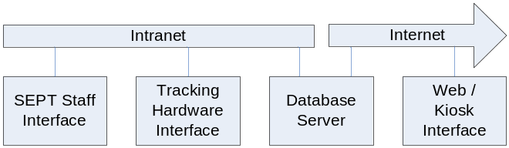
Figure 2.1-1: Block diagram of the system components

The SEPT staff interface will provide all authorized hospital staff with the ability to access patient, equipment and supplies information as well as the tracking features of the system. The web/kiosk interface will provide visitors and patients with hospital information and the room of patients whom have consented to their location being disclosed. The tracking hardware interface relays signals from the sensing equipment to the software system. All tracking data and patient records are served from the database server which is accessed over the hospital’s Intranet and externally to the website via the Internet.

Product Functions
The SEPT system has the following features:
- Patient medical records may be accessed
- A patient's current location in the hospital may be tracked
- Medical equipment may be signed out and tracked
- Supply stock information may be maintained
- Room and bed availability status may be maintained
- Hospital and patient visitation information shall be publicly available through the Internet
- Access permission groups may be managed
- Security personnel may monitor patients and equipment in real time

User Characteristics
There are five main groups of users who will use the system, each with their unique requirements and varying technical skills levels.

Administrative personnel
Administrative personnel require that all hospital operations, from mundane to system-critical, run efficiently and without problem. Administrative personnel will have extensive management experience and a detailed working knowledge of most the hospitals operations.

Healthcare personnel
The doctors and nurses require immediate access to patient information and medical equipment. Healthcare personnel have had experience with data entry and computer applications as used in the old system, or at other hospitals or elsewhere.

Security personnel
Security requires that all medical equipment and patients are in their correct locations and that restricted areas are not breached. The security personnel have extensive experience monitoring outputs of systems and responding to alerts.

Supply staff
The supply staff requires that data entry of supply stock be as efficient and accurate as possible. They also have had extensive experience with data entry with mainly Microsoft Access.

Patients and Visitors
Visitors require access to general patient information (room number and visiting hours) from the Internet and on-site kiosks. The technical skill level and physical capabilities of the visitors and patients will vary greatly from extremely limited to very high.

Constraints
As per St. Peter’s Hospital’s request, the development of this system must be constrained in the following ways:
- The implementation of this system must not disrupt the hospital’s operation during the transition from the current systems.
- The system must be maintained by at most three IT technicians.
- Training must be provided by Tri-Systems to familiarize the hospital’s employees with the system before it goes online (employees are not available for training more than two days per month).
- St. Peter’s Hospital reserves the right to terminate the project at no extra expense if the project fails to meet its proposed deadline.
- Due to limited funding for this project, the hospital will not be able to pay more than 25% above the estimated project cost.

Assumptions and Dependencies
In order for the SEPT system to function, the following assumptions and dependencies apply:

The current Oracle DBMS will be available for use by the new system
In accordance with the St. Peter’s Hospital request (in their RFP) the system must operate using their current version of Oracle DBMS. This existing Oracle DBMS will be used as one of the three Oracle DBMS systems required to run the new system as per the specs in this document (see 3.3.1 for additional information on triple redundancy.)

User computers are available and networked to the hospital’s Intranet
The system is dependent on all staff computers being connected to the hospital’s Intranet for secure access to the database server.

Security cards have been issued and readers are located at computers where needed
For secured user login the system requires that the staff have been issued keycards and that their computers are equipped with a card reader if needed.

Approval has been granted to access the provincial EMS system
This is required for interfacing with the systems own medical history database.

Specific Requirements

Functionality

Patient medical records may be accessed
As requested in the RFP, this is required to provide healthcare personnel with immediate information for properly treating patients and to provide administrative personnel with usage information.

By default, the system shall store patient information
From the RFP, and negotiations, the system will store the following information by default. The following is defined as the default because additional fields may be added as defined in 3.1.1.2. This requirement is based on Use Case 1: Finding and Editing Information for Patient (4.3.1).
- Identifying information (Name, Date of Birth, Care Card number)
- Current prescriptions and administered medication
- Current condition
- Assigned doctor(s)
- Listing of scheduled procedures or operations
- Visitation history (reason for visit, length of visit)
- Medical history
Test Scenario: Information about a test patient is stored on the system. The system is queried with the identifying information for the test patient. When successful, the correct patient information associated with the identifying information in the database is displayed on the screen.

Patient information fields can be added, removed or re-labeled
As requested during negotiations, administrators can add, remove or re-label the fields that store the information that is editable by healthcare personnel in the patients information screen. (Reworded as requested in feedback to RS 2.0.)
The following details respond to the concern about error responses noted in the feedback to RS 2.0: Any changes (addition, modification and removal of fields) will require the user to confirm the change. In the event that an error occurs the change will not be made and the user will be notified.
Test Scenario: the system is used to add, delete and modify a test patient information field. The system is queried with a test patient. When successful, the system displays the test patient with the added field. The system does not display the deleted field. The system displays the new field name.

Patient information fields shall be read-only, read/write, or read/add
As requested during negotiations, patient information fields can be protected by assigning different levels of access to them. These access levels include read only, read/write, or read/add only. Read only refers to the ability to view what has already be entered into that field, but not modify its contents. Read/write gives full access to that field to view what is already there and make changes to it. Read/add refers to the ability to read and add an additional item to the field, but not remove any information that was already there. (More detail added as requested in feedback to RS 2.0.)
Test Scenario: Permissions are assigned to three fields. Field 1 is read only. Field 2 is read/write. Field 3 is write only. A test patient is added to the system. The system is queried for the test patient. Then fields 1,2 and 3 are modified. When successful, the system is queried and displays field 1 and field 2. When the system is modified, it displays an error when field 1 is modified.

The system shall allow new patients to be added
This is essential for the continued use of the system. Name and healthcare number are required for creating a new patient. Medical history and contact information will be retrieved from the provincial EMS.
Test Scenario: A new patient is added to the system. The system is queried with the new patient identifying information. When successful, the system displays the correct information about the new patient.

The system shall log changes made to patient information
As requested during negotiations, tracking changes to all medical information provides a way of tracing incorrect changes to the person who made them. During further discussion it was decided that the following information will be logged:
- The user who made the change
- What was changed (including the previous value)
- When the change was made
It was also requested during the negotiations that there be some way to notify the user viewing the record that a particular field has a change log (such as a flag beside the field that link to the change history). The change logs shall not be modifiable by anyone.
Test Scenario: A test patient is stored on the system. Its information is modified. A query is made to the system for the test patient information. Another query is made to the log for the patient information. When successful, the modifications to the information are successful. The log is successfully updated and the results to the log query show the correct information.

The system shall obtain medical records from the British Columbia medical record system
As requested during negotiations, the provincial EMS information shall be available as part of a patient’s medical record that is maintained in the system. Whenever a patient’s information is requested, the system shall query the provincial medical record system for additional data.
The following clarification was requested in the feedback to RS 2.0. The request is placed on a queue and is handled as soon as possible (in most cases this will be immediately after being queued), but in the event that the provincial medical record system is down, the query will remain in the queue until it can be processed. Once the query has been completed it will update the records inside the SEPT system (if appropriate) with the new information. The user will be notified that the system cannot communicate with the provincial medical record system at this time and that the information will be updated as soon as possible.
Test Scenario: Authorized medical staff may access the patient information tab within the patient tracking interface. This patient document will automatically synchronize with provincial medical records. On successful retrieval and synchronization a success message will appear.

The system shall update provincial medical records to the provincial medical record system
As requested during negotiations, patient information maintained in the system shall be able to update provincial EMS data with new medical information and history. When a patient’s information is updated in the system, the new data is added to a queue that will be sent to the provincial database when possible.
The following clarification was requested in feedback to RS 2.0. As mentioned above, any updates requiring to be published to the provincial medical records system is added to a queue. The entries in the queue are published to the provincial medical record system as soon as possible (in most cases immediately upon being added to the queue), but in the event that the provincial medical record system is unavailable the updates will remain in the queue until they can be published. The system will present the user with a visual notification cautioning them that their changes may not appear in the provincial medical record system immediately because SEPT is having difficulties communicating with the system at this moment. This notification will also reassure the user that all changes have been recorded by SEPT.
Test Scenario: Authorized medical staff may access the patient information tab within the patient tracking interface. After the user makes their desired changes they may click the submit button for the system to send the current copy to the provincial medical records. Upon success, there will be a message displaying "Update Successful". Otherwise there may be a failure message if an error occurred during the update.

The system will track the current locations of patients in the hospital.
As requested in the RFP, this is required so patients may be quickly located for immediate treatment and monitoring entry to restricted areas.

Patient's location shall be displayed as the current building, wing, floor and room that they are in
As requested in the feedback to RS 2.0, patient’s location will consist of the building name, wing, floor number and room number that they are presently in.
Test Scenario: Authorized medical staff will use the patient tracking interface on login and enter search criteria for the specific patient they seek. Upon a successful search they can click the resulting patient within the search result list and their location on a map is displayed on the right panel.

A patient's current location shall be updated automatically and in real-time
As stated in the RFP, knowledge of the patient’s location is only valuable if it is up-to-date and automatically updated by the system. This further detail was requested in the feedback to RS 2.0: a patient’s location is only updated when the patient moves through a door equipped with tracking sensors. If a patient is not presently moving the system will have the up-to-date location of the patient in the system already. Subject to the performance requirement 3.4.1.
Test Scenario: Once the tracking information of a patient is selected and displayed, when the patient passes sensors the system will automatically update the database accordingly and update the display of the user interface reflecting their current location last detected by the tracking sensors.

Patients shall be identified by searching by information or location
As requested during negotiations, in order to find a particular patient, a user may search any of the patient information fields for matching criteria. A user may also search by requesting which patients are in a specified location. Locations may be a particular room or floor in the hospital.
Test Scenario: Once the tracking interface is accessed, a search interface is available allowing for patient information or location to be searched. On success a list fitting the criteria will be displayed on the list of search results. If a location is searched for, such as a room, then all patients within that room will be displayed in the results.

Medical equipment shall be recorded, tracked, and signed out
As requested in the RFP, the tracking of equipment shall be automated and signing out shall be digitized.

The following information shall be stored by the system
As requested in the RFP, the system will store the following information about medical equipment:
- Staff member who signed out item
- Sign out time
- Sign in time
- Duration item was signed out
- Intended destination of item
- Current location of item
This requirement is based on Use Case 2: Finding and Editing Information for Equipment (4.3.2).

Equipment shall be signed-out whenever it is in use
As requested during negotiations, hospital staff will sign-out a piece of equipment through the system when it is being taken into an area where it will be used. Equipment that is in use has an intended destination, which is input by the user when it is signed-out. Equipment that is not signed-out is expected to be in a storage room, ready to be signed-out when needed. This requirement came from Use Case 3: Signing out equipment (4.3.3).

The system shall store and monitor stock information
As requested in the RFP, the supply staff is responsible for storing and monitoring supply levels to ensure that stock never runs out by alerting the appropriate staff of low supplies.

The following supply information shall be stored by the system:
As requested in the RFP, the system will store the following information:
- Product information
- Stock in warehouse
- Minimum supply level (used to trigger low supply notifications)
The minimal supply level will accept an integer value to represent a suitable quantity for the supply it is associated with. When the quantity of a supply drops below the minimum supply level associated with it, a notification will be generated. (Requested in feedback to RS 2.0.)
This requirement arose from Use Case 7: Creating an In-House Supply Order (4.3.7).

The system will notify the administrative personnel and supply staff when stock is low
As requested in the RFP, low supply alerts will notify staff to re-stock supplies in order to prevent potential problems during emergencies.
This clarification was requested in response to RS 2.0. When the quantity of a supply drops below the minimum level it will generate a low stock notification that is added to a queue. This notification will be displayed to all administrators and supply staff when they are logged into the system until the supply level is restocked.

Supply inventory history shall be stored for 1.5 years
As requested during negotiations, supply inventory history will be maintained and cannot be deleted for a minimum of 1.5 years from the date of entry. After 1.5 years has passed the data shall be available for removal by the system administrator.

The system shall store room and bed availability status
As requested in the RFP, this will allow fast allocation of rooms to patients in need.

The status of beds and rooms is associated with the patients occupying it
When a patient has an assigned to a room and bed, the room and bed availability is automatically updated. (Requested in the RFP and updated in response to the feedback to RS 2.0.) This allows for the most accurate count of beds and rooms in use or available. Beds have the following statuses: available, occupied, requires maintenance and requires cleaning. Rooms have the following statuses: empty, partially filled and full.

Information maintained on bed availability is to consist of which building, wing, floor number and current status
As requested in the feedback to RS 2.0, the information that is to be maintained about bed availability will consist of bed number, which building, wing and floor is it located on, as well as whether it is currently occupied.

Hospital and patient visitation information shall be publicly available
As requested in the RFP, this will be provided through the hospital’s website and on-site visitor information kiosks. This feature came from Use Case 4: Using the Kiosk/Website (4.3.4).

The system shall allow users to access general information about the hospital
Requested in the RFP. To enable users to gain a better understanding of St. Peter’s Hospital including, contact information, history and services offered.

Website and visitor information kiosks shall provide floor plans of hospital
Requested in the RFP. To help users locate rooms and specific departments in the hospitals, reduce the number of questions asked to staff which decreases their work load and allowing them to be more productive in other areas.

The system shall provide visitors with the hospital's visiting hours
This informs potential visitors of hospital visiting hours so they visit at the allowed times preventing the occurrence of confused and frustrated visitors.

Website shall allow users to obtain a map of the hospital's location
This is to aid visitors and patients to plan their commute to the hospital.

Website and visitor information kiosks shall display patient's room numbers
As requested in the RFP, and clarified during requirements elicitation, patient’s room numbers will be available on the web and through visitor information kiosks. This allows visitors to find the location of the patient easily. Patient consent is required to allow the hospital to comply with privacy laws and giving patients the choice to allow their name to be listed if they expect many visitors.

The website shall present specific, plain language error message to the user in the event of a failed transaction
This is to avoid any confusion of the user and to protect sensitive data being dumped to the screen from a default error message (functionality added from feedback to RS2.0).

Users and groups may be created and access permissions shall be modified

Administration staff shall be able to create new users and groups
As requested during negotiations, members of the administration user group will have the ability to create new users and groups, as well as modify the permissions of the groups. Requirement extracted from Uses Case 5: Creating users, user groups, and setting permissions (4.3.5).

The system shall restore previous group permission if a fatal error occurs during a transaction
This will prevent erroneous permission settings to be stored in the system by reverting to the previous settings and displaying a message to the user (clarification requested in feedback to RS2.0).

The system shall provide default user groups
The default user groups, as initially requested in the RFP, shall be:
- Administrative personnel
  - Access to all system functionality (no restrictions shall be placed upon this group)
- Healthcare personnel
  - Access to patient tracking and records
  - Access to equipment tracking and sign-out
- Security personnel
  - Access to patient tracking
  - Access to equipment tracking
- Supply staff
  - Access to supply stock maintenance
- Visitors
  - Access to website and visitor information kiosks

Group access to system functionality shall be restricted by the group’s permission settings
As requested during negotiations, permissions settings shall control the user group’s access to the system functionality (tracking, signing out equipment), as well as their ability to change the information in the system.

Security personnel may monitor patients and equipment in real time

The system shall alert security personnel if restricted areas of the hospital are accessed by unauthorized patients
As requested in the RFP, security staff shall receive notification when restricted areas are breached.
Additional detail requested during feedback to RS 2.0 follows. Notifications are added to a queue and displayed to all security personnel currently logged in to the system. It will remain in the queue until it is manually removed by security staff. If no security personnel are logged into the system at the time of the alert then the alert will be displayed at the next security staff login.

The intended location of the patient shall be recorded.
As requested in the RFP, security personnel must be aware of where the patients are intended to be in order to effectively monitor their movements.

The system shall alert security personnel in the event that equipment has been moved from its designated location.
As requested in the RFP, this allows security personnel to respond to possible theft of expensive and important medical equipment, as the reduction and prevention of theft or loss of this equipment is one of the main focuses of this project.

Notifications can be created, modified and deleted.
During negotiations the request to add the ability to create, modify and delete notifications from the system was made to coincide with Use Case 6: Adding and Removing Tracking Notifications (4.3.6).

Usability

Users shall be able to learn how to use the system within 16 hours of training
As indicated in the RFP, healthcare staff will not have more than two days per month for professional development training, thus complete familiarity with the system must be gained within this time.

The user interfaces shall be intuitive
To accomplish this, user interfaces will borrow from familiar applications such as spreadsheet-style data entry, Google-style search, and architectural floor plan style location output. The effectiveness of the user interfaces will be evaluated through user testing prototypes throughout the development process.

Tracking hardware must be robust and unobtrusive
This will contribute to the user-friendliness of the system requested in the RFP. Evaluation and testing of selected tracking hardware will be performed during the development process to the following criteria:
- Absolutely no interference with the operation of the medical equipment;
- Compatibility with the existing system components;
- Life span of 3 to 5 years; and
- Appropriate size and fit.

Check-in time shall take a maximum of 15 seconds in the event of an emergency
As requested during negotiations, this allows for immediate tracking of the patient. Information may be added to the patient’s record at another time.

Reliability

Patient medical records must be available 100% of the time
As requested in the RFP, access to patient records must operate with zero downtime as doctors treating patients in critical condition depend on the information stored in the records. This is required for at least one server to be operational if a server fails or if upgrades are being performed.
During negotiations, it was decided that triple redundancy for the core hospital system shall be implemented in order to support this requirement. Redundancy is not necessary for servers hosting the visitor information kiosks and website.

Daily backups of medical record, equipment status, and supply stock databases will be performed
As requested in the RFP and further clarified during negotiations, all system data shall be backed up daily at 2:00 AM to an offsite location. Only changes made during the day will be updated.

Performance

The location updates shall be propagated to the system within 20 seconds of detection
As requested during negotiation, this is necessary for everyone to have the same information about any given situation. Although the intent is that equipment and patient locations shall be updated as soon as a sensor picks them up, delays may occur in the case of network congestion. Up-to-date information is essential for a reliable system that will be used continuously.

Visitor information kiosks shall handle transactions from a minimum of 2000 users per day
As per the request of St. Peter’s hospital during requirement elicitation.

The hospital website shall support a minimum of 20,000 users per day
As per the request of St. Peter’s hospital during requirement elicitation.

The disk space on the database server shall never exceed 75% capacity
This will ensure that there will be enough memory to hold the data received until the next data removal. In the event that this limit is exceeded the data that is also stored on the provincial medical record system and has not been accessed in the last year will be purged.

Supportability

The system shall be upgradeable on a modular basis
This will allow changes to be made to one area of the system without disrupting any of the other functionality. This was requested from the clients as feedback to RS 2.0.

Administrative personnel shall have direct access to the Oracle DBMS software
If required due to flawed input or data inaccuracy the administrative personnel shall be able to manually set fields in the databases through Oracle’s administration software.

Existing databases will be migrated to the Oracle DBMS
Electronically setting up stock and equipment information in the new database server, rather than performing a full inventory throughout the whole hospital, will be preferable.

Changes to provincial database will require an update to be applied
As requested in the feedback to RS 2.0, the system will be provided such that it is compatible with the current provincial medical record system at time of delivery. If the way data is stored in the provincial medical record system is modified in the future an update to the system will be required. Please contact us for a quote for the required modifications.

Design Constraints

The user interfaces shall run on the existing staff computers to access the system
The system user interfaces must run on the existing staff computers, many which are approximately eight years old and running Windows NT 4.0.

Software components which users do not have access to shall in no way be displayed to them
As requested in prototype feedback, any buttons or tabs that a user does not have access to shall not be displayed to them and should be removed from the display.

Online User Documentation and Help System Requirements

The website shall host a help file for all of its functionality
As per feedback from St. Peter’s Hospital on version 1.0 of this document.

Each system user group shall have a customized manual
As per St. Peter’s Hospital’s request, all functionality will be documented and each user group (administrative, healthcare, security, supply staff) shall have a user manual created customized to their permission to access that functionality. Soft and hard copies shall be provided.

Purchased Components

Visitor information kiosks must meet the following specifications:
The kiosks require personal computers with networking capabilities and must be able to run Damn Small Linux 2.2 with Firefox (or alternatively Windows NT 4.0 with Internet Explorer).
The cost of the kiosks will be included in the bill for the entire system's hardware infrastructure.

System devices will be equipped with backup battery supplies
The hospital currently has a backup generator in the case of a power outage, but there is a small delay in starting up the backup power in the event of a power outage. A backup power supply connected to each server, network device, tracking interface node, and computer is necessary to keep the system running during this small delay. The system must run on its backup power for approximately one hour in the event that the hospital’s backup power doesn’t start immediately.

The system shall require additional servers for redundancy and backups
More servers are required if Tri-Systems Incorporated is to guarantee a given up-time. Since software updates are necessary, hardware does fail, and the requirement for the system is to be up 100% of the time, more redundancy is needed in terms of backups for application servers and database servers.
The cost of the servers will be included in the bill for the entire system's hardware infrastructure.

Interfaces

User Interfaces
Two main user interfaces will be created for the system. The first incorporates all the features detailed in section 3.1 accessible by the hospital staff. The second interface is for the visitor and patient information accessible from the hospital’s website and information kiosks. See Section 4.4 Prototypes for more descriptions of the proposed interfaces.

Hardware Interfaces
All system components except the servers must execute from a personal computer. The servers will run on designated server machines. Additionally the Tracking and Supply Inventory interface components will interact with system hardware as described in the following sections.

Tracking Interface

The tracking interface shall connect the tracking hardware to the SEPT system
This allows the tracking hardware to update the SEPT information management system.
- Tracking devices are attached to specific equipment and patients (in wristbands).
- Tracking sensors are installed in doorways and at required points in long hallways.
- A group of tracking sensors is connected to a tracking interface node.
- When a tracking sensor detects a tracking device, it sends the ID of the tracking device along with the tracking sensor ID to its tracking interface node.
- When a tracking interface node receives the ID of a sensor and tracking device it adds it to the queue of updates to send. Update messages are queued to reduce the amount of network traffic generated by the tracking system.
- All update messages in the queue are packaged into an xml message and sent via the hospital’s Ethernet intranet to the main server. From the last update, the delay until the next update is between 10 and 30 seconds. This optimization is to reduce periodic congestion from all tracking interface nodes transmitting data at the same time.
- The xml message is sent using the http protocol. The xml message is of the following format:
<tracking_updates>
<update>
<interface_node>332</interace_node>
<authentication_code>99B3388d8d8dd8</authentication_code>
<sensor_id>994fa325</sensor_id>
<device_id>883ab33d0033</device_id>
<time>20061024193344</time>
</update>
...
</tracking_updates>
- To reduce the traffic on the network, tracking interface nodes cache
- If the server acknowledges the update (“HTTP/1.1 200 OK” header returned) the query is removed from the tracking interface node, otherwise transmission is attempted again.

Keycard Readers

The staff computers shall be interfaced with keycard readers to provide fast and easy logging in
As requested during the elicitation and discussions, scanning of a valid keycard shall replace the necessity to enter a username and password to access the system.
The reader will connect to the computers through a USB or a serial connection, whichever is available on the computer.

Software Interfaces

RS54 The system shall interact with an Oracle Database Management System
As requested in the RFP, the SEPT system must make use of the existing Oracle DBMS.

RS55 An HTTP server shall be used for hosting the website
In order to host the website, the hospital will need a server with an Internet connect running an HTTP server. The server must also be running a dynamic content technology for interfacing with the Oracle DBMS.
Setup of the server and registration of any IP address or domain names shall be provided by Tri-Systems.

RS56 The system shall interact with the British Columbia provincial health record database
As requested during the negotiations, the system will be able to access patient records that are stored in an existing external provincial database. The system will also be able to update this database with new patient records and changes to existing records. Specifically, whatever information that is contained in an Electronic Medical Summary will be obtained and used by the system as patient data.

Communications Interfaces

RS57 All user components of the system shall communicate via TCP/IP over the hospital's Intranet and the Internet
As discussed during the elicitation, this ensures a common protocol for all components in the system to communicate over the existing network.

Licensing Requirements
All software developed by Tri-Systems Incorporated is subject to the Berkeley Software Distribution license.

Legal, Copyright and Other Notices
This document and all parties discussed in this document are part of a semester project for the spring 2006 offering of the University of Victoria’s Software Engineering 321 course.

Applicable Standards

All website components shall be programmed with valid XHTML 1.0 Transitional markup
Valid XHTML 1.0 Transitional markup will provide the best accessibility while still maintaining backwards compatibility with older browsers.

User interfaces must adhere to the accessibility standards
As requested in the RFP, all interfaces complying with accessibility standards laid forth by Microsoft, W3C, and the US Government will provide the best usability for physically challenged parties.

System Architecture

Overall Architecture
The core of the system architecture consists of modules used by hospital staff and administration. The Web/Visitor Module is separate from the hospital core for increasing security and modularizing the functional components. The hospital core contains a module for each of the main functions required by the system, and the tracking core that is used by two modules that share some similar functions.
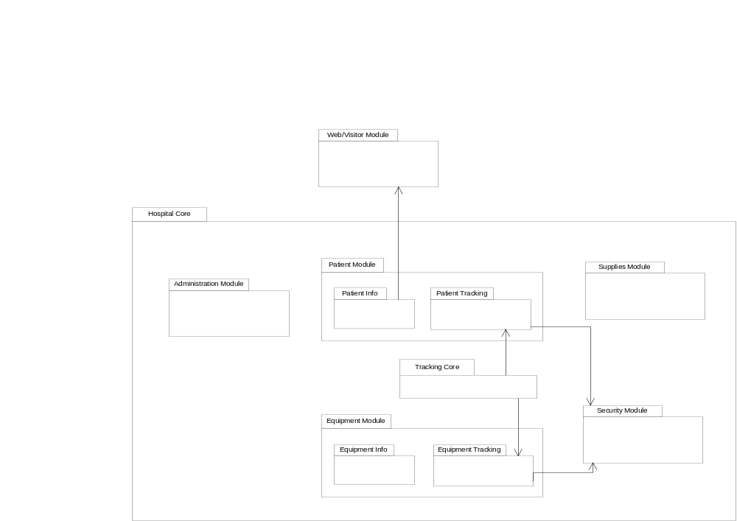
Figure 4.1-1: Software System Architecture

Software Modules

Administration Module
The administration module provides user and group creation, modification and deletion and modifications to permissions for each group. The permissions set using the administration module govern the entire system. The administration module targets hospital administrators providing them the tasks to manage and support the system.

Patient Module
This is the largest and most important module of the system which provides access to a huge array of patient information (such as medications, allergies and medical history) that is stored and constantly updated by staff. The patient module encompasses the patient information and patient tracking components.
The patient information component is responsible for interfacing with the main database providing up to date information to users with appropriate permissions. The tracking component communicates with the tracking core to maintain and display the location of patients in the hospital. This component plots and updates patients’ locations on a map of the hospital.

Equipment Module
The equipment module manages equipment information and equipment location. The equipment information component is responsible for communicating with the main database providing detailed information. The tracking component communicates with the tracking core to maintain and display the location of equipment in the hospital. This component plots up-to-date equipment location on a map of the hospital.

Supplies Module
The supply module provides inventory management and notifications for low levels of supplies. This module interfaces directly with the supply database.

Web/Visitor Module
The web/visitor module provides general hospital information (visiting hours, floor plans and maps) and a patient’s room location. This module interfaces with the patient module to access their room location.

Security Module
The security module provides advanced monitoring of patients and equipment. Notifications can be set to alert security personnel when patients or equipment move in or out of designated areas. This module interfaces with the patient tracking component of the patient module and equipment tracking components of the equipment module.

Tracking Core
The tracking core is an interface that facilitates the storing, updating and querying of tracking information from the database. It is used by the patient and equipment tracking components.

Use Cases
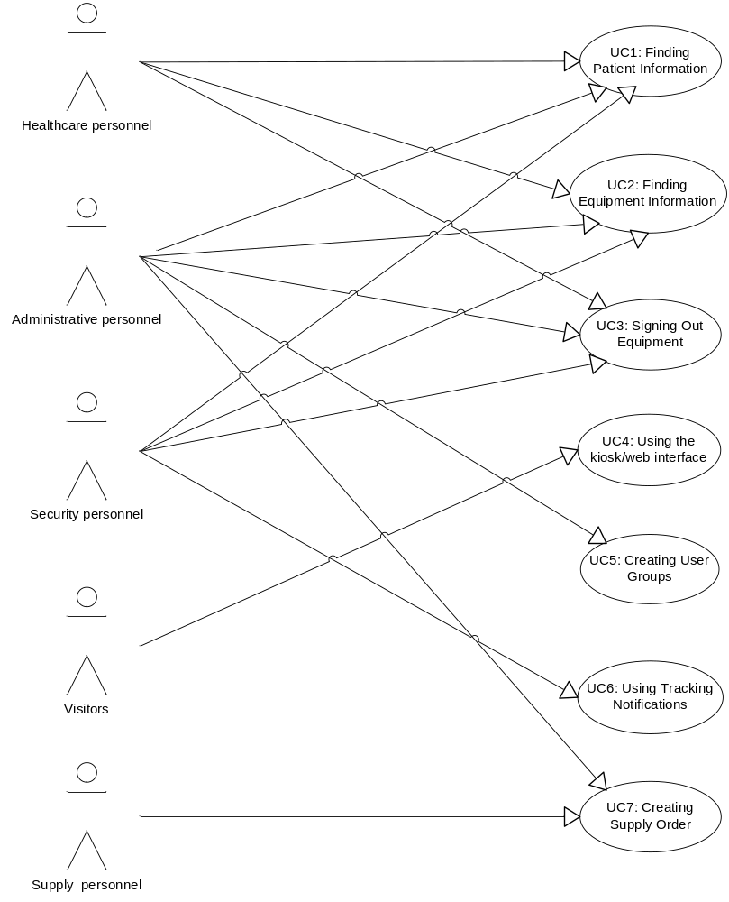
Figure 4.3-1: Use case diagram of the system

Use Case 1: Finding and Editing Information for Patient
Actors: Healthcare, Administrative, and Security personnel.
Purpose: To identify a patient, and view or add to the patient’s medical record.
Description: A user searches for a patient based on information about it that they already know such as a name, or a unique identification number. They may then select the desired patient from a list of matching results, and view or add to that user’s medical record.
Preconditions: User belongs to a Healthcare, Administrative or Security user group, is currently logged into the system, and has the correct permissions to access the appropriate information (i.e. – users in the Security user group do not have permissions to view patient medical records).
Postconditions: Viewed information is correctly retrieved from the database. Changed information is correctly updated in the database. Search results and search interface are still available to user.

Primary Scenario
Actor Action | System Response
- User enters the Patient screen from the Main Menu.
 | - System presents the user with the correct user interface.
- User enters search criteria and searches for a patient.
 | - System presents a list of patients matching the search criteria.
- User selects a patient from the list.
 | Possible Alternatives: See 6a, 6b
- User views desired information.
 | Possible Alternative: See 7a.
- User ends session.

Alternative Scenarios and Extensions
6a. User wants to find the location of a patient.
6a-i. User requests the patient location information from the user interface.
6a-ii. System presents supply staff with a map detailing the location of the selected patient.
Return to Step 3, 5 or 6 in primary scenario.
6b. User wants to view detailed information about the patient.
6b-i. User requests the detailed patient information user interface.
Possible Alternative: See 6c.
6b-ii. System presents user with specific information about the selected patient, and all patient medical records.
Return to Step 3, 5, or 6 in primary scenario.
7c. User wishes to make an entry in the patient medical record.
7c-i. User fills in entry on the patient information screen.
7c-ii. System indicates that the user is creating a new entry for the patient.
7c-iii. User clicks the “Add Entry” button.
7c-iv. System requests confirmation from user that the information should be stored in the patient’s record.
7c-v. User confirms the addition with the system.
7c-vi. System updates the database with the new information.
Return to Step 3, 5, or 6 in primary scenario.

Use Case 2: Finding and Editing Information for Equipment
Actors: Healthcare, Administrative, and Security personnel.
Purpose: To identify a piece of equipment, and view or change information about it.
Description: A user searches for a piece of equipment based on information about it that they already know such as a name, or a unique identification number. They may then select a desired item from a list of matching results, and view or change information about that piece of equipment.
Preconditions: User belongs to a Healthcare, Administrative or Security user group, and is currently logged into the system.
Postconditions: Viewed information is correctly retrieved from the database. Changed information is correctly updated in the database. Search results and search interface are still available to user.

Primary Scenario
Actor Action | System Response
- User enters the Equipment screen from the Main Menu.
 | - System presents the user with the correct user interface.
- User enters search criteria and searches for a piece of equipment.
 | - System presents a list of items matching the search criteria.
- User selects an item from the list.
 | Possible Alternative: See 6a
 | - System presents user with a list of specific information about the selected piece of equipment.
Possible Alternative: See 7a
- User views desired information and either ends the session or returns to step 12 to select another item.

Alternative Scenarios and Extensions
6a. User wants to find the location of a piece of equipment.
6a-i. User requests the equipment location information from the user interface.
6a-ii. System presents supply staff with a map detailing the location of the selected piece of equipment
Return to Step 7 in primary scenario.
7a. User wishes to change some information about a piece of equipment.
7a-i. User selects the information they want to change.
7a-ii. System indicates that the user is changing the selected field of information.
7a-iii. User enters new information.
7a-iv. System requests confirmation from user that the new information should be stored.
14a-v. User confirms the change with the system.
7a-vi. System updates the database with the new information.
Return to Step 7 in primary scenario.

Use Case 3: Signing out equipment
Actors: Healthcare, administrative, and security personnel.
Purpose: To track hospital equipment through a semi-automated system.
Description: Staff members can sign-in and sign-out equipment through a computer interface. The information is stored in a database.
Preconditions: A staff member wants to sign-in or sign-out a piece of equipment.
Postconditions: The following information is associated in the database: The equipment ID, staff member’s ID, sign-out time, sign-in time, intended destination and current location of the equipment.

Primary Scenario
Actor Action | System Response
- User logs in.
 | - System prompts user with menu choices: patients, equipment, supplies or administrative tools.
- User selects equipment.
 | - System displays equipment main menu.
See alternative 5a
- User searches for the desired piece of equipment.
 | - System displays a list of equipment matching the search criteria.
- User selects the desired piece(s) of equipment. User selects sign-in/sign-out.
 | - System displays sign-in/sign-out menu for that piece(s) of equipment. System prompts user for information.
- User enters information and selects sign-out.
 | See alternative 10a
 | - System processes request. System displays success. System prompts user for verification.
- User verifies request.
 | - System returns to equipment menu.
- User selects main menu.
 | - System displays main menu.
- User logs out.

Alternative Scenarios and Extensions
Actor Action |  | System Response
5a. User wishes to sign-in a piece of equipment.
5a-i. User selects sign-in/sign out.
 |  | 5a-ii. System displays sign-in/sign-out menu. System displays a list of all equipment currently signed out by the user.
5a-iii. User selects desired piece of equipment and selects sign-in.
Return to step 10 in primary scenario
10a. There is an error in the request
 |  | 10a-i. System alerts user and returns to the equipment menu.
Return to step 12 in primary scenario

Use Case 4: Using the Kiosk/Website
Actors: Visitors and potential patients
Purpose: Allow visitors to obtain patient room location and general hospital information.
Description: Visitors can access patient room location and general hospital information through a local kiosk at St. Peters Hospital or through the hospital website.
Preconditions: (i) Patient consent for release of their location.
(ii) Visitor has patient’s name to access their location information
Postconditions: Visitor successfully enters the patient name and obtains their room
location or other general information such as contacts and visiting hours.

Primary Scenario
Actor Action | System Response
- Visitor accesses the kiosk/website.
 | - System displays a page with available navigation menu and hospital welcoming page.
Possible Alternatives: See 3a, 3b and 3c
- Visitor chooses patient information.
 | - System displays an input field to enter the patients name.
- Visitors inputs and submits patient name
 | Possible Alternative: See 6a
 | - System displays where the patient is located. (Building, floor, room)

Alternative Scenarios and Extensions
Actor Action | System Response
3a. Visitor wishes to access general hospital information
3a-i. Visitor chooses general information
 | 3a-ii. System displays introductory information about the hospital including its history.
 | Return to step 3 in primary scenario
3b. Visitor wishes to access contact information
3b-i. Visitor chooses contact info
3b-ii. System displays a map of the
location of the hospital, address,
and contact numbers.
 | Return to step 3 in primary scenario
3c. Visitor wishes to access visiting hours
3c-i. Visitor chooses visiting hours.
3c-ii. System displays general hospital
visiting hours.
 | Return to step 3 in primary scenario
6a. Patient information could not be retrieved
 | 6a-i. System displays patient information could not be retrieved. Due to a non-existent patient or patient consent was not given for the release of their location.
 | Return to step 4 in primary scenario

Uses Case 5: Creating users, user groups, and setting permissions
Actors: Administrators
Purpose: Creation of users, user groups and setting permissions to allow different groups of users have different permissions.
Overview: Administrator logs in to the system. Then he/she creates a new user. Based on the type of the user, administrator will put user into different group and which gives user appropriate permissions.
Preconditions: Administrative personnel log in to the system.
Postconditions: All changes made by administrative personnel should be updated immediately.

Primary Scenario
Actor Action | System Response
- Administrator chooses user and group management option.
 | - System presents administrator with the user interface consisting of a list of user group.
- Administrator selects desired the user group from the list.
 | Possible Alternative: See 4a
 | - System displays the permissions of the selected user group and its current user list.
- Administrator selects desired the user from the list.
 | Possible Alternative: See 6a
 | - System displays the permissions of the selected user.
- Administrator chooses change permissions option.
 | - System displays the choices of all groups.
- Administrator select the new user group to desired the user.
 | - System updates the user’s permissions and group membership in the system.
- Administrator ends the process.

Alternative Scenarios and Extensions
4a. The desired user group is not in the list.
4a-i. Administrator selects add new user group.
4a-ii. System will presents administrator with empty form for a new user group.
4a-iii. Administrator fills in the group name, gives appropriate permissions and chooses create.
4a-iv. System adds new user group to database.
Return to Step 3 in primary scenario.
6a. The desired user is not in the list.
6a-i. Administrator selects add new user.
6a-ii. System will presents administrator with empty form for a new user.
6a-iii. Administrator fills in the user name and user’s information such as name, keycard number, ID, SIN, address etc. As well the user must be put into a user group.
6a-iv. System updates the user information in the database.
Return to Step 5 in primary scenario.

Use Case 6: Adding and Removing Tracking Notifications
Actors: Security Staff
Purpose: To add and remove alerts for tracked equipment and patients.
Description: Security staff can add or remove tracking notifications that will notify them when either a certain piece of equipment is moved out of an authorized area, or a patient moves into a secure area.
Preconditions: Security staff member is identified and authenticated.
Postconditions: A new notification has been added to the system, or a notification has been removed.

Primary Scenario
Actor Action | System Response
- Security staff selects “Notifications” option.
 | - System displays the notifications screen consisting of a searchable list of current notifications.
Possible Alternatives: See 3a and 3b
- Security staff selects “Add Notification” option.
 | - System displays add notification screen.
Possible Alternatives: See 5a
- Security staff enters search value for desired equipment item(s).
 | Possible Alternatives: See 6a
 | - System displays results.
- Security staff selects one or more entries from list to add notifications to and chooses “Add” option.
Possible Alternatives: Return to 5 to add more items/patients.
 | - System adds entries to notification being created.
- Security staff enters start and end dates (optional), selects the type of notification, urgency of notification and who to notify, then selects the “Add Notification” option.
 | - System completes the addition of new notification to the system and returns security staff to list of notifications.

Alternative Scenarios and Extensions
3a. Security staff wishes to view details of existing notification.
3a-i. Security staff clicks on row containing existing notification in list.
3a-ii. System presents security staff with details entered when creating notification as well as log containing items monitored by this notification that have triggered notifications with the most recent at top.
3a-iii. Security staff can return to previous menu by choosing “Back” option.
Return to Step 3 in primary scenario.
3b. Security staff wishes to remove existing notification.
3b-i. Security staff chooses “Remove” option from beside notification they wish to remove.
3b-ii. System displays a confirmation dialog.
3ab-iii. Security staff chooses confirm.
3b-ii. System removes entry and
updates list.
Return to Step 3 in primary scenario.
5a. Security wishes to add patients to notification.
5a-i. Security staff enters search value for desired patient(s).
Return to Step 6 in primary scenario.
6a. No matching results found.
6a-i. System notifies security staff that no matching entries were found.
Return to Step 5 in primary scenario.

Use Case 7: Creating an In-House Supply Order
Actors: Supply staff member (also may be preformed by Administrative personnel)
Purpose: To select which items will be moved form the warehouse to a location inside the hospital.
Description: Supply staff creates a list of desired supplies to be sent to a location inside the hospital, which is then logged by the system for completion.
Preconditions: Supply staff member is identified and authenticated.
Postconditions: A list of items is logged. Destination location is correctly identified. Supply locations, quantities, and status are correctly updated in the supply stock database.

Primary Scenario
Actor Action | System Response
- Supply staff selects the in-house order option.
 | - System presents supply staff with the correct user interface.
- Supply staff searches for desired item.
 | Possible Alternatives: See 4a, 4b.
 | - System presents a list of relevant items matching the search criteria.
- Supply staff selects the appropriate item and enters the needed quantity.
 | - System adds the item to the displayed list of items in the order.
- Supply staff enters the desired destination location and confirms the order.
 | - System logs the list, destination, time, supply staff username, order number as pending completion.
Possible Alternative: See 9a.
- Supply staff ends session.

Alternative Scenarios and Extensions
4a. No relevant items were found during the search.
4a-i. Supply staff selects add new stock.
4a-ii. System presents supply staff with empty form for a new item.
4a-iii. Supply staff enters the item name, identifying number, quantity, status (on hand, on order, or in hospital), then confirms entry.
4a-iv. System adds new item to database.
Return to Step 3 in primary scenario.
4b. Displayed item information is incorrect.
4b-i. Supply staff selects edit supply item.
4b-ii. System presents supply staff with populated form of the items information.
4b-iii. Supply staff makes the desired changes and confirms the entry.
4b-iv. System updates the item information in the database.
Return to Step 5 in primary scenario.
5a. Supply staff has delivered the order and wants to confirm it.
5a-i. Supply staff selects the order number from the list of pending orders and confirms it completion.
5a-ii. System updates the item’s information in the database.
Return to Step 9 in primary scenario.

Prototypes

Main Menu
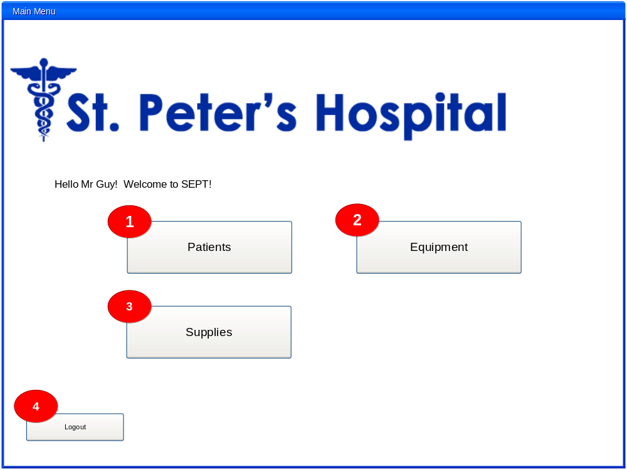Figure 4.4-1: Main Menu

When logged in, the user is presented with the main menu. All screens the user has access to are displayed on this screen. In this example, the user (Mr. Guy) has permissions to access the Patients screens (1), the Equipment screens (2) and the Supplies screens (3). Pressing one of these buttons will take the user to that group of screens.
Pressing Logout (4) will log the user out of the system (the system also logs the user out automatically after 20 seconds).
Since the current iteration of the requirement specification focuses on the Patient module, the screenshots shown here will revolve around that part of the system.

Patient Information Screen
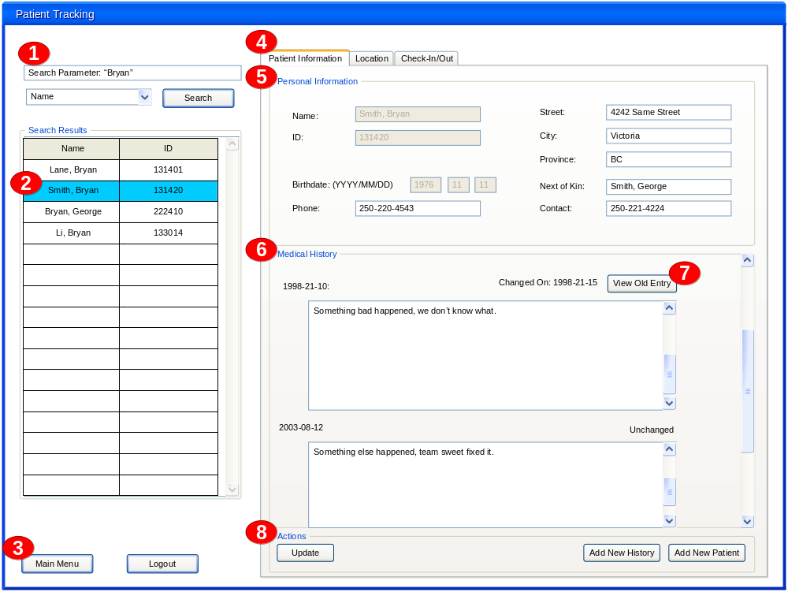
Figure A1-2: The Patient Information Screen

The Patient Information screen allows users to view and edit information about a selected patient.
To search for a patient:
- Type the search parameter in the search box (1) and select what type of parameter to search for using the drop-down box located below the search box.
- Press the search button to perform the search.
- Select a patient from the search results found in the search results list (2). This fills in the information for any of the tabs shown on the right-hand portion of the screen with information that applies to the selected patient.
To return to the main menu, or logout of the system, use the buttons (3) found below the search results box.
To view a patient’s information, select the patient information tab (4) found at the top of the screen. Under this tab, you can view a patient’s personal information (5) and their medical history (6).
If an item of medical history has been changed or updated, the modification date and “view old entry” button (7) will be shown above the modified entry. Pressing the “view old entry” button will display the original medical history item, highlighting the changes and display the name of the person who made the modification.
If any of the information fields were edited by the user while viewing this screen, pressing the update button (8) will confirm and apply these changes. The “add new history” button will create a new medical history item, allowing a user to fill in the information to be displayed. The “add new patient” button creates a new patient and presents the user with a screen with which they can fill in the information for the new patient.

Patient Location Screen
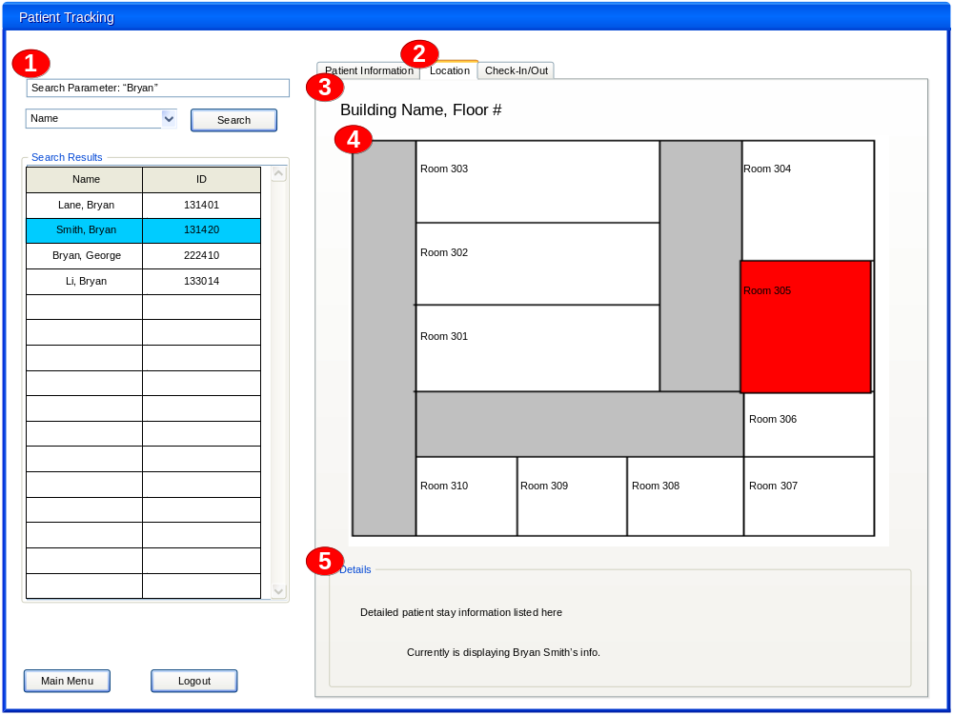
Figure A1-3: The Patient Location Screen

The patient location screen displays information about a patient’s current location.
(1) To select a patient follow the search procedure as outlined in A1-2.
To view the patient’s location, select the location tab (2) found at the top of the screen. The building name and floor number (3) of the floor plan (4) indicate the patient’s current location. The area that the patient is currently in is highlighted in red. Some detailed information (5) about the patient’s location is displayed below the floor plan.

Patient Check-In and Check-Out Screen
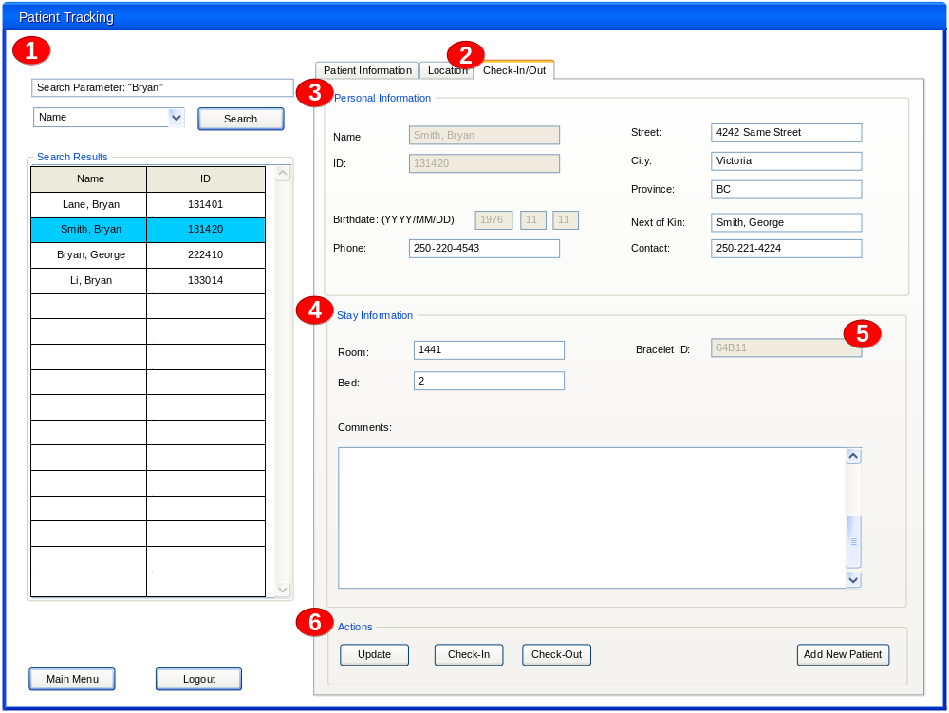
Figure A1-4: The Patient Check-In and Check-Out Screen

The patient check-in and check-out screen displays some personal information about the patient, as well as their current stay information.
(1) To select a patient follow the search procedure as outlined in A1-2. Alternatively, if the patient is already checked in the bracelet can be scanned which will fill in the information for that patient.
To access the check-in and check-out screen, select the check-in/out tab (2) found at the top of the screen. Patient information (3) is shown here to be easily viewed or edited when the patient is checking in. This information is the same as would be found under the patient information tab. The stay information (4) about the patient is displayed below the personal information.
The patient’s bracelet is scanned into the system as they are checked in. When successfully scanned, the bracelet id box (5) will automatically be filled with the bracelet’s unique identification number.
Changes made to the personal information are confirmed and applied by pressing the update button (6). The check-in button confirms and applies the checking in process, and the check-out button does the same for the check out process.

Appendix A: Requirement Priority
The following table shows the priority of the requirements for the main functionality of the system (locating patient records and viewing medical records):
Requirement | Priority
3.1.1.1 By default, the system shall store patient information | High
3.1.1.2 Patient information fields can be added, removed or re-labeled | Moderate
3.1.1.3 Patient information fields shall be read-only, read/write, or read/add | High
3.1.1.4 The system shall allow new patients to be added | High
3.1.1.5 The system shall log changes made to patient information | Moderate
3.1.1.6 The system shall obtain medical records from the British Columbia medical record system | Moderate
3.1.1.7 The system shall update provincial medical records to the provincial medical record system | Moderate
3.1.2.1 Patient's location shall be displayed as the current building, wing, floor and room that they are in | Low
3.1.2.2 A patient's current location shall be updated automatically and in real-time | High
3.1.2.3 Patients shall be identified by searching by information or location | Moderate
3.2.1 Users shall be able to learn how to use the system within 16 hours of training | High
3.2.2 The user interfaces shall be intuitive | Moderate
3.2.3 Tracking hardware must be robust and unobtrusive | High
3.2.4 Check-in time shall take a maximum of 15 seconds in the event of an emergency | High
3.3.1 Patient medical records must be available 100% of the time | High
3.3.2 Daily backups of medical record, equipment status, and supply stock databases will be performed | Moderate
3.4.1 The location updates shall be propagated to the system within 20 seconds of detection | Moderate
3.4.2 Visitor information kiosks shall handle transactions from a minimum of 2000 users per day | Low
3.4.3 The hospital website shall support a minimum of 20,000 users per day | Low
3.4.4 The disk space on the database server shall never exceed 75% capacity | Moderate

Appendix B: Traceability Matrices

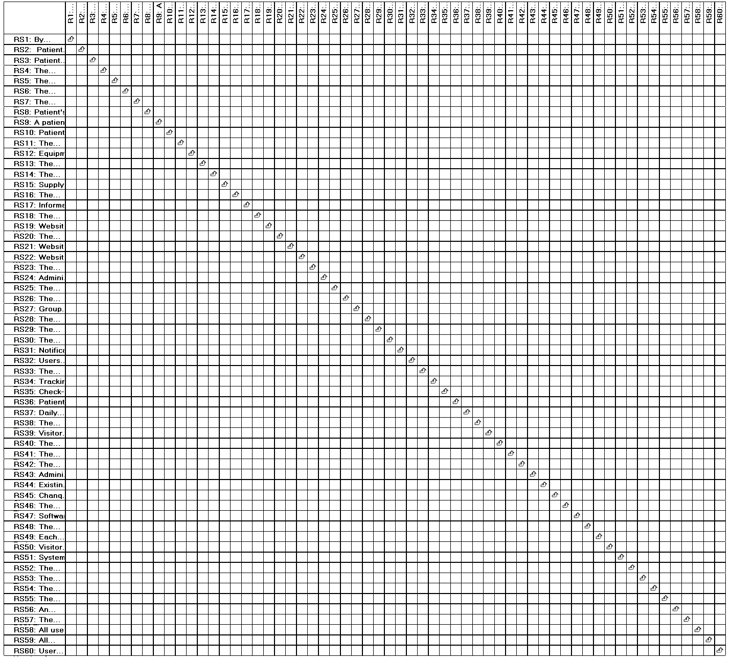
Figure B-1: Rationale to Requirement Traceability Matrix

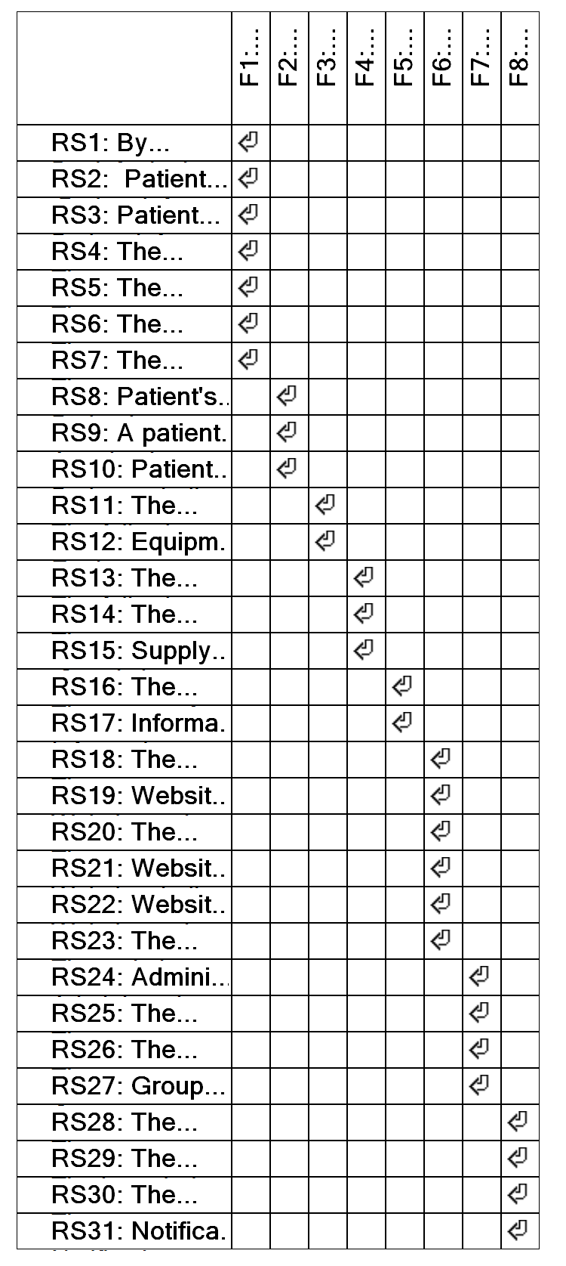
Figure B-2: Feature to Requirement Traceability Matrix
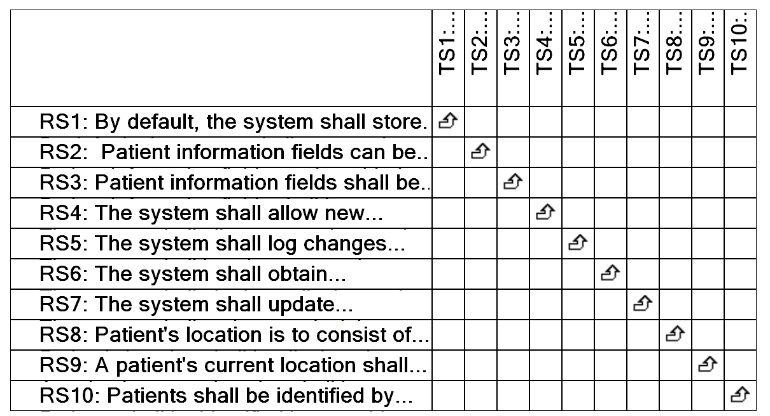
Figure B-3: Test Scenario to Requirement Traceability Matrix

Appendix C: Change Log

Section | Change | Source/Reason
1.3 | Dictionary definition of stock added to glossary. | Source: Feedback to RS 2.0.  Reason: Client requested definition of stock.
2.5.1 | Additional information and clarification added to remove redundancy. | Source: Feedback to RS 2.0.  Reason: Client requested for further clarification to how their current Oracle DBMS will be used in the new system.
2.5.4 | Assumption of approval to access provincial medical records. | Source: Feedback from RS 2.0  Reason: Logistics behind access to provincial medical records are currently unknown.
3.1.1 | Included test scenarios for this section’s requirements | Source: Tri-Systems Inc.  Reason: To provide procedures for verifying the requirements.
3.1.1.1 | Added reference to Use Case 1. | Source: Feedback to RS 2.0.  Reason: Because it was missing and to create better traceability.
3.1.1.2 | Added field creation and customization functionality. | Source: Negotiations meeting.  Reason: Client request for more flexibility within the system.
3.1.1.2 | Clarification of the fields that can be added, removed or relabeled by administrators. | Source: Feedback to RS 2.0.  Reason: Client requested for additional information.
3.1.1.2 | Additional clarification added when creation, modification or deletion of custom fields fails. | Source: Feedback to RS 2.0.  Reason: Client requested for additional information on what would happen if task failed.
3.1.1.3 | Clarify the permissions assignable to patient information fields. | Source: Feedback to RS 2.0.  Reason: Client requested for additional information.
3.1.1.4 | Handling of patients not and record. | Source: Negotiations meeting.  Reason: Requirements for special cases that may occur.
3.1.1.5 | Logging of changes in done through the system when they occur. | Source: Negotiations meeting.  Reason: Allow for tracking of changes made for traceability.
3.1.1.5 | Marked fields of recently changed information. | Source: Negotiations meeting.  Reason: Allow for traceability of previous changes and when they occurred.
3.1.1.5 | Logs must not be modified | Source: Feedback on RS 2.0  Reason: Previously discussed with client, but initially overlooked.
3.1.1.6 &  3.1.1.7 | Requested functionality of provincial medical record system interface. | Source: Negotiations meeting.  Reason: Client requested for this set of functions to be available through this interface.
3.1.1.6 &  3.1.1.7 | Addition of case when provincial medical record system is unavailable. | Source: Feedback on RS 2.0.  Reason: Client requested additional detail for error case.
3.1.1.6 &  3.1.1.7 | Reword requirement titles. | Source: Feedback on RS 2.0.  Reason: Client requested clarification of BC medical records system.
3.1.2 | Re-wording of feature to reduce ambiguity. | Source: Feedback on RS 2.0.  Reason: Change requested by client to reduce ambiguity.
3.1.2 | Included test scenarios for this section’s requirements | Source: Tri-Systems Inc.  Reason: To provide procedures for verifying the requirements.
3.1.2.1 | Additional requirement added clarifying patient tracking detail. | Source: Feedback on RS 2.0  Reason: Client requested that patient can be tracked by the following information: building, wing, current floor, room number
3.1.2.2 | Additional information added to clarify when the location of a patient in the system is updated. | Source: Feedback on RS 2.0  Reason: Client requested additional clarification.
3.1.2.3 | Patient search criteria. | Source: Negotiations meeting, prototype feedback  Reason: Client requested for advanced searching capabilities
3.1.3.1 | Added reference to Use Case 2. | Source: Feedback to RS 2.0.  Reason: Requested by client, as it was missing and to create better traceability.
3.1.3.2 | Added reference to Use Case 3. | Source: Feedback to RS 2.0.  Reason: Requested by client, as it was missing and to create better traceability.
3.1.4 | Re-worded feature to make clearer and more concise.. | Source: Feedback to RS 2.0.  Reason: Client requested for better defined feature and rational.
3.1.4.1 | Added reference to Use Case 7. | Source: Feedback to RS 2.0  Reason: Requested by client, as it was missing and to create better traceability.
3.1.4.1 | Added clarification of level of detail that can be specified. | Source: Feedback to RS 2.0  Reason: Client requested for additional detail.
3.1.4.2 | Added further details on notifying administrators and supply staff when supplies low. | Source: Feedback on RS 2.0  Reason: Client requested for additional information.
3.1.4.3 | Supply history and logs kept for minimum of 1.5 years. | Source: Negotiations meeting.  Reason: Allows for manual backup by technical staff.
3.1.4.3 | Clarification of how the data will be removed. | Source: Feedback on RS 2.0  Reason: Previously an implied requirement.
3.1.5.1 | Clarification of requirement title, and room and bed availability status. | Source: Feedback to RS 2.0.  Reason: Client requested for additional detail.
3.1.5.2 | Detail the information maintained about bed availability. | Source: Feedback to RS 2.0.  Reason: Client requested that the information maintained about bed availability consist of: bed number, which building, wing and floor is it located on, as well as whether it is currently occupied.
3.1.5 | Re-worded of feature to make more clear and concise. | Source: Feedback to RS 2.0.  Reason: Client requested for better defined feature and rational.
3.1.6 | Added reference to Use Case 4. | Source: Feedback to RS 2.0.  Reason: Requested by client, as it was missing and to create better traceability.
3.1.6.6 | Added error condition functionality. | Source: Feedback to RS 2.0  Reason: Inquiry by client.
3.1.7 | Users and group permissions. | Source: Negotiations meeting, prototype feedback  Reason: Clients requested functionality to group and customize user permissions.
3.1.7.1 | Added reference to Use Case 5. | Source: Feedback to RS 2.0.  Reason: Requested by client, as it was missing and to create better traceability.
3.1.7.2 | Addition of error case. | Source: Feedback to RS 2.0  Reason: Additional detail for error case requested by client.
3.1.7.4 | Rewording of title of requirement to make clearer. | Source: Feedback to RS 2.0.  Reason: Client requested for change.
3.1.8.1 | Addition of error case. | Source: Feedback to RS 2.0.  Reason: Additional detail for error case requested by client.
3.1.8.1 | Clarification of requirement. | Source: Feedback to RS 2.0  Reason: Client found the wording confusing.
3.1.8.2 | Improved wording consistency. | Source: Feedback to RS 2.0  Reason: Previously had confusion between the words “intended” and “allowed”.
3.1.8.4 | Requirement and reference to Use Case 6 added. | Source: Negotiations meeting and feedback on RS 2.0.  Reason: Requirement requested, and addition of reference to use case requested to increase tractability.
3.2.2 | More specific description of location output. | Source: Feedback to RS 2.0  Reason: Client request.
3.2.3 | Addition of evaluation details. | Source: Feedback to RS 2.0  Reason: Requested information for evaluation and testing of tracking hardware.
3.2.4 | Check-in time for emergency. | Source: Negotiations meeting.  Reason: Required for the design of the implementation of the system to satisfy the fast paced environment in an emergency.
3.3.1  3.8.3 | Triple redundancy for main database and server. | Source: Negotiations meeting.  Reason: To allow zero downtime as requested by the clients.
3.3.1 | Explanation of how redundancy affects failure/upgrades. | Source: Feedback to RS 2.0.  Reason: Client requested clarification.
3.4.1 | Monitored tracking devices locations updated within 20 seconds. | Source: Negotiations meeting.  Reason: Requirement stated by the client.
3.4.1 | Worst possible system delay due to congestion. | Source: Negotiations meeting.  Reason: Requirement for the worst case scenario of system delay.
3.5.1 | Added requirement of modular upgrades. | Source: Feedback to RS 2.0.  Reason: Client request.
3.5.2 | Clarified reference to Oracle’s DBMS software package. | Source: Feedback to RS 2.0.  Reason: Client requested clarification.
3.5.3 | Requirement added to reliability section to specify what happens when the provincial medical records system updates how their database is accessed. | Source: Feedback to RS 2.0.  Reason: Client requested that requirement be added.
3.6.1 | Clarification between using the computers for the system back end and accessing information. | Source: Feedback to RS 2.0.  Reason: Client requested that requirement be clarified.
3.7.2 | Clarified any ambiguity between user groups and user modules (note: the idea of user modules was removed after RS1.2). | Source: Feedback to RS 2.0.  Reason: Client requested that requirement be clarified.
3.8.1 | Clarification of requirement. | Source: Feedback to RS 2.0  Reason: Client was unclear on the wording of the requirement.
3.9.2.1.1 | No changes. We feel that the level of detail is necessary. | Source: Feedback to RS 2.0  Reason: Client requested removal of detail.
3.9.3.2 | Responsibility of web server setup assigned to Tri-Systems. | Source: Feedback to RS 2.0.  Reason: Beyond client’s expertise.
3.9.3.3 | Add interface to provincial medical record system. | Source: Feedback to RS 2.0.  Reason: Provide access to patient information and medical records stored in the provincial system.
3.12.2 | Details of accessibility standards. | Source: Feedback to RS 2.0.  Reason: Client requested specific sets of standards.
4.4 | Included prototype descriptions | Source: Prototype presentations.  Reason: To clarify the reader’s understanding of requirement implementation.
Appendix A | Included requirement priorities | Source: Tri-Systems Inc.  Reason: To better define the order of implementation of the requirements
Appendix B | Included traceability matrix | Source: Tri-Systems Inc.  Reason: Improve traceability of requirements

